


Project Navodaya

ABAP Technical Specification

Document Information

Document Number
Title | RAP Application for Manage Incident Report
Document Purpose | Graphical representation for Manage Incident Report
Key Words
Document Status | Final
Contact for Enquiries | Arnav

Document Change Control :
Release | Description | Created by | Date | Reviewed by | Date | Approved by | Date
01 | RAP Application for Manage Incident Report | Arnav | 02-02-2026

Header
Area (R/3Module): | EHS |  |  |  |  | Date: |  | 02-02-2026
Requested by: | GAIL EHS Team
Title: | RAP Application for Manage Incident Report
Short description: | Graphical representation for Manage Incident Report
Functional Developer: | Sunil Jawalkar (SAP) |  |  |  |  |  | Phone: | +91
Technical Developer: | Arnav Johri |  |  |  |  |  | Phone: | +91 9971324400
Program name:
Type: | Change Request Development Request(Creation) Rework
Program type: (select the check box) | Conversion Batch Interface Online Interface Report  Form Enhancement Extension Dialog  Modification Unknown Others BAPI  ALE/ IDOC Application Development
Priority: | Very High High Medium Low
Complexity: | Very High High Medium Low
Specify known SAP functionality: |  | <Specify the related SAP transactions>
Cross Reference Documentation:
Only for Interfaces:  Type of interface:  Direction of interface:  Frequency: |  |  |  | Real-Time Batch  Inbound Outbound Both  Daily Weekly Monthly  Biweekly Other:
Only for Reports:  1. The report will be created via:  2. Requested characteristics: |  |  | Standard Report  Report Painter Report Writer ABAP Query  ABAP Program Info System  Drill-down Pushbuttons Sort  Entry files Others: _____________________
Generic question:  1. Impact of not creating the program: |  |  | legal requirements will not be fulfilled  lack of information required for the business  lose functionality compared to the old system  others: could have duplicate data entered into the system_
Development labor estimate:
Are there any alternatives in the standard system: |  |  |  |  | Yes No
Describe the alternative found:
Reason why this alternative was not acceptable: |  |  |  |  | Performance problems Complexity  Others: The transaction to initiate

Technical Specification
3.1. Technical Report Created:

Root CDS: YC_MANAGEINCIDENT_FINAL
Entity Set: YC_MANAGEINCIDENT_MAIN
ODATA Service: YC_MANAGEINCIDENT_MAIN_CDS

Development Overview

Sr. No | Program Name | Transaction Code | Transport Request No | Dependency/ TR Sequence
1 | Manage Incident Report |  | DVRK9A1O08

Development Details

Code

Screen:

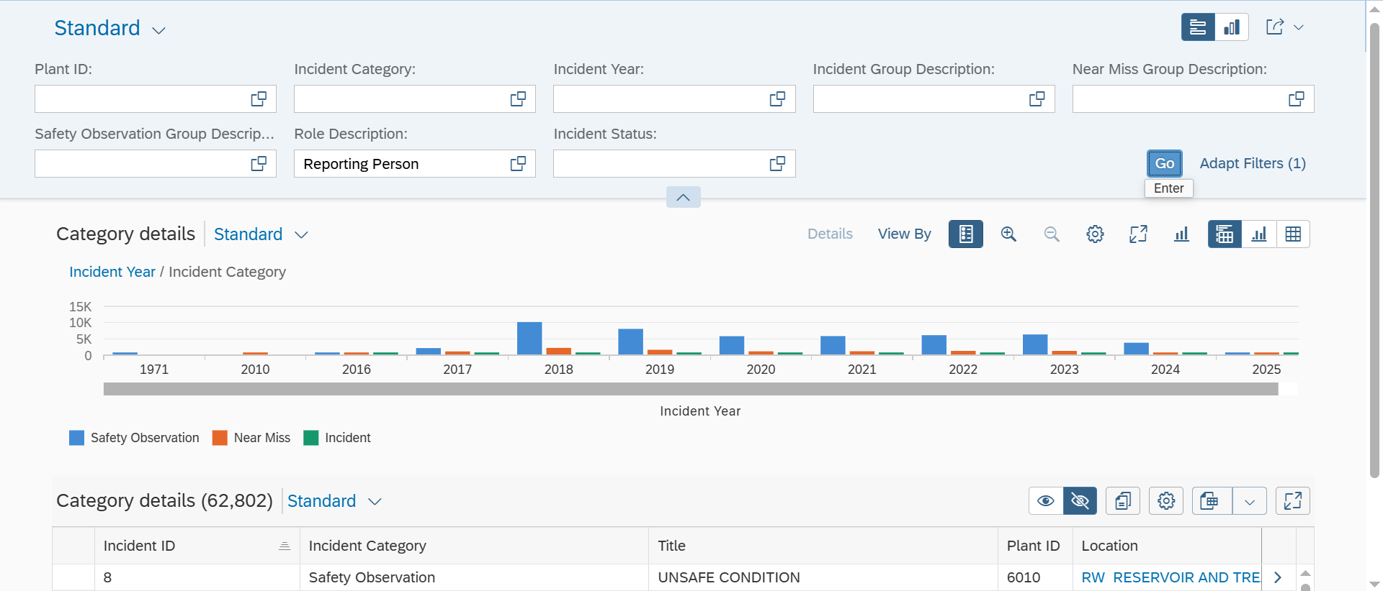

Logic:

- CDS: YCDS_MANAGEINCIDENT
This CDS view serves as the base data source for the Manage Incident RAP application. It consolidates incident master data with related roles, groups, and investigation details, derives incident year and month and records for further processing.
- CDS: YC_MANAGEINCIDENT_TABLEFUNC
This table function enriches Manage Incident data by deriving and concatenating incident, safety observation, and near-miss group codes and descriptions. It is implemented via an AMDP method, providing processed and reusable group information for consumption in RAP CDS views.
- CDS: YCL_MANAGE_INCIDENT
This AMDP class implements the table function logic for Manage Incident processing. The SQLScript method aggregates incident, safety observation, and near-miss group codes and descriptions using STRING_AGG, removes duplicates, and returns consolidated incident-level data for RAP consumption.
- CDS: YC_MANAGEINCIDENT_FINAL
This final CDS view consolidates Manage Incident data by combining the base incident CDS with the table function output. It aggregates incident attributes, enriches group codes and descriptions, and provides a single, flattened dataset optimized for RAP consumption.
- CDS: YC_MANAGEINCIDENT_CUBE
This CDS cube view builds on the final Manage Incident CDS to support analytical reporting. It enriches incident data, value helps, and associations, applies aggregations for measures, and structures dimensions for consumption in analytical queries.
- CDS: YC_MANAGEINCIDENT_MAIN
This main CDS analytical query view projects data from the Manage Incident cube and is exposed via OData. It defines filters, rows, and columns for incident analysis, enabling users to report and drill down on incident details, categories, statuses, groups, and time-based trends.
- Metadata:
Once the data is fetched from the CDS, a metadata is created to define the UI of the fiori app.
- Service Definition Exposure:
Once the metadata is defined for the CDS view entity elements, it is exposed through a service definition. This step makes the data accessible for external systems to consume.
- Service Binding and Maintenance:
The service definition is bound and maintained. This ensures that the service is available to the desired applications and users.
- Fiori Tile Creation and Role Assignment
A Fiori tile is created to display the data exposed by the service. Additionally, roles are assigned to ensure that only authorized users can access and view this tile.

Table Creation
N/A

Security /Authorization
N/A

User Exit
N/A

Transaction / Batch Job that will access enhancement
N/A

Anticipated performance Issues (if any)
N/A

Registration
N/A

Assumptions/ Notes

Unit Test Case
Screenshot for testing

- Report Screen:

N/A

- Fiori Screen:

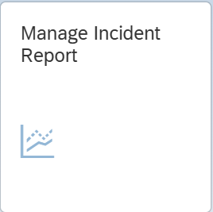



Technical Spec Original Sign Off:

Names and Signatures:

_____________ARNAV_______________________________ Date: ___02/02/2026________

____________________________________________________ Date: _____________

____________________________________________________ Date: _____________

____________________________________________________ Date: _____________

Modifications
< Description of Modification if any>
<Support document of the modification like screen shot of email received>

